

**RESPONSE TO RFP**

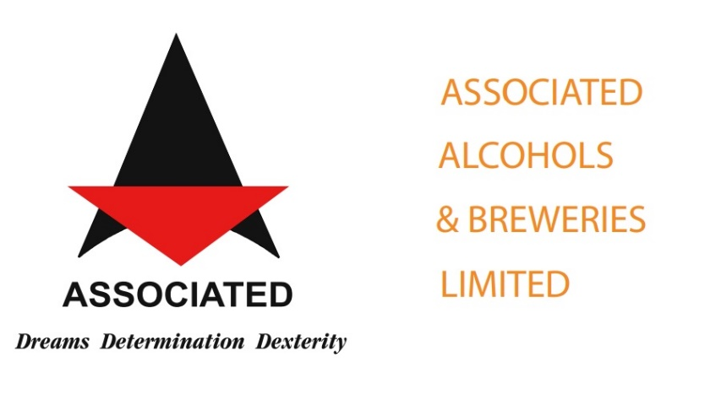

**Associated Alcohols & Breweries Ltd., Indore**

For

Automated Invoice processing

Submitted by:

**Sanjeev Kumar Vyas**

Manager – Sales

**Netlink Software Private Limited**

**Email**: [skvyas@netlink.com](mailto:skvyas@netlink.com), **Mobile**: +91- 9630022763, **Website**: www.netlink.com

Table of Contents

1. Introduction and Background 3

a) Cover Letter 3

b) Executive Summary 3

2. Project scope 6

3. Proposed Solution 7

**Option1: ERPNext** 7

**Option 2: Oracle Apex** 10

Execution Approach 16

Project Methodology 16

Planning 17

Analyze 17

Design 17

Development 17

Deployment 18

Post Deployment 18

Timeline 18

Team Structure 18

4. Financials 19

1. Introduction and Background
2. Cover Letter

Associated Alcohol & Breweries Limited (AABL)

Subject: Response to the RFP for Automated Invoice Processing.

Netlink appreciates this opportunity to bid for AABL’s requirement for Automated Invoice Processing. Netlink hereby transmits Associated Alcohol & Breweries Limited (AABL) a proposal in response to the Request for Proposal (RFP). Netlink acknowledges receipt of all requirements issued by Associated Alcohol & Breweries Limited (AABL) in our proposal.

This letter is Netlink’s formal offer to perform the services described in this proposal. This proposal is firm for a period of sixty (60) days from the date of submission.

The individual signing this letter is authorized to bind the prospective respondent, contractually as described in the proposal and is the point of contact designated by Netlink.

Submitted by:

**Netlink Software Private Limited**

Sanjeev kumar Vyas, Manager - Sales

Email : skvyas@netlink.com

Mobile : +91- 9630022763

Website: www.netlink.com

1. Executive Summary

We would like to thank you for giving Netlink the opportunity to participate in this RFP proposal for Automated Invoice Processing. We appreciate the opportunity given to Netlink to provide services to Associated Alcohol & Breweries Limited (AABL) and continue a strong business relationship for years to come.

Netlink is confident that it possesses the necessary capabilities, expertise, and experience in fulfilling and exceeding the requirements specified in the RFP as well as helping Associated Alcohol & Breweries Limited (AABL) realize its strategic initiatives of optimization with positive and delightful user experience.

Netlink will provide Associated Alcohol & Breweries Limited (AABL) an application that will automate their invoice processing.

Netlink believes in building a long-term partnership with the clients and has designed its pricing proposal accordingly while offering solution to automate their invoice processing.

1. About Netlink

In 1998, Anurag Shrivastava had an idea, and the blueprint of an IT start-up was drawn. The vision was to create a data-driven platform to benefit aspiring young professionals. The outcome was Netlink – a value-added technology and business solutions provider that propels innovation and transformation with a mission to help companies reach peak performance with the technology solutions and services they need. Today, Netlink has more than ten offices worldwide leveraging streamlined processes, advanced systems, superior technology, and proven expertise to deliver robust IT solutions.

In 2013, Lumenore was born out of the Netlink Group to address the business needs arising from data explosion. With a pedigree of building business-solving technologies, Netlink always had a pulse on the market.

Lumenore was founded on the belief that powerful technology does not have to come at the cost of accessibility. We began this journey to ensure that data literacy does not become an arms race, where you are getting more and varied customer data and investing heavily in analysts to interpret it. Data literacy today needs to stand for easier access to decision-driving analytics - instead of being bottlenecked by a few experts at your company. That is why democratizing access along with simplifying insights are core values at Lumenore.

Premier provider of value -added technology and business solutions.

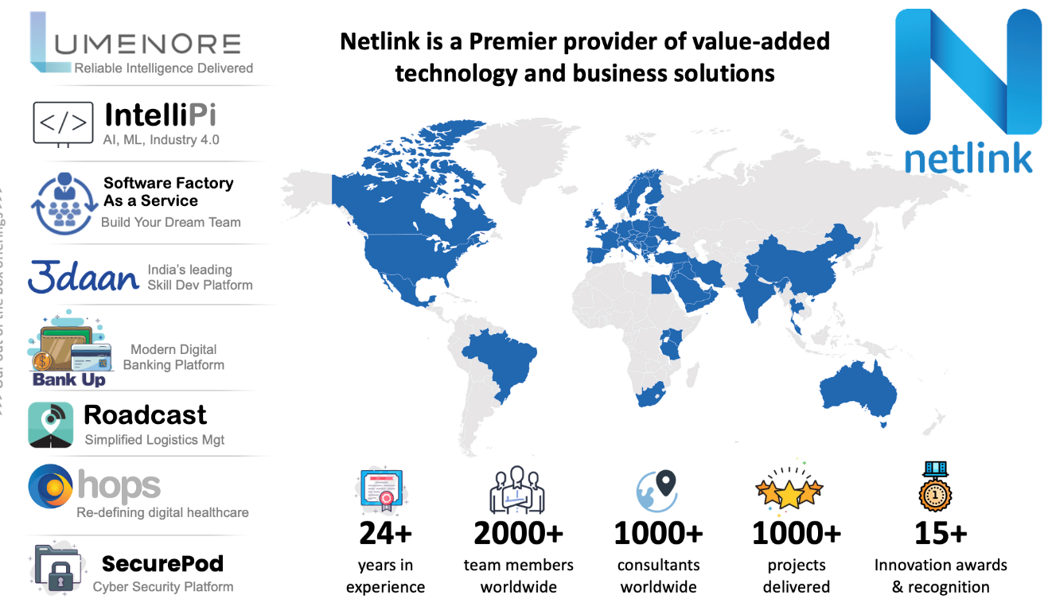

With a mission to help companies reach peak performance with the technology solutions and services they need, today Netlink has more than ten offices worldwide leveraging streamlined processes, advanced systems, superior technology, and proven expertise to deliver robust IT solutions.

Netlink, operating from Michigan US, Dubai and 3 locations in India, was built to give organizations high-quality insights through an easy-to-use powerful solution. Since then, we have empowered scores of organizations to build a culture of data.

**Service Verticals**

For the past 24 years Netlink has envisioned and created best of service delivery ecosystem providing following services to global customers

* Digital Transformation
* BI and Analytics Services
* Software Factory as a Service
* Enterprise Mobility
* Infrastructure and Cloud
* ERP Services
* RPA (Robotic Process Automation)
* Low-Code Services
* Al & Machine Learning Services
* BPO (Business Process Outsourcing) Services
* Document Imaging Services
* Industry 4.0
* Skill Development
* Billing Solution
* Incentives, HR & Payroll

Netlink team over period of 2 decades have acquired various badges and certifications across different technologies and institutions.

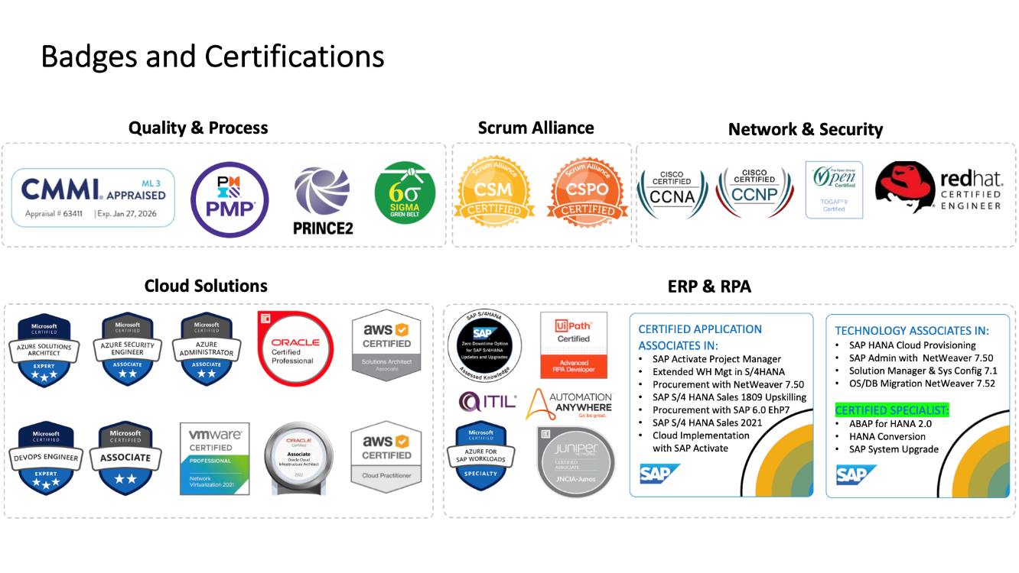

We have provided delightful experience to 100+ customers across the world with different domains and verticals.

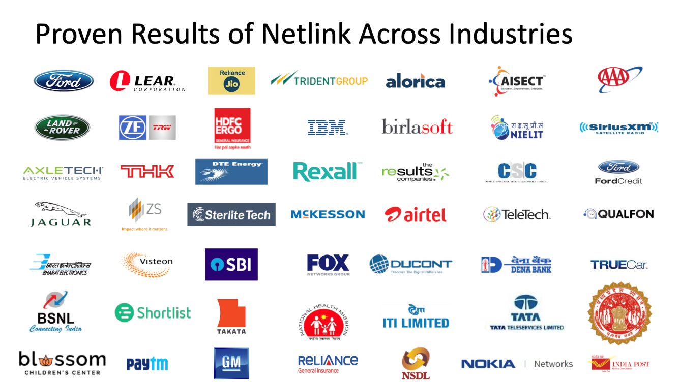

Technologies that we have expertise in

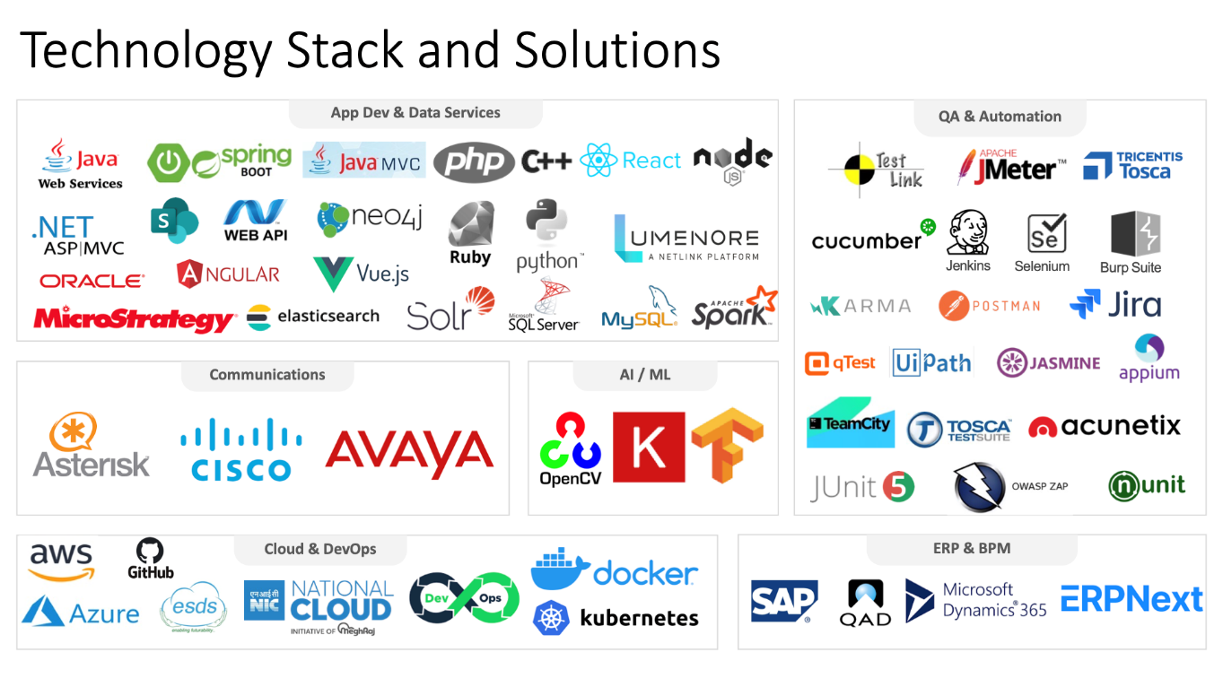

Netlink with its domain expertise and varied experience is able to deliver the results to our clients 100% each time just because of a simple fact that we get our best teams forward to understand what you want, brainstorm as if its their own business and then how to shape the solution to make it work according to the requirements.

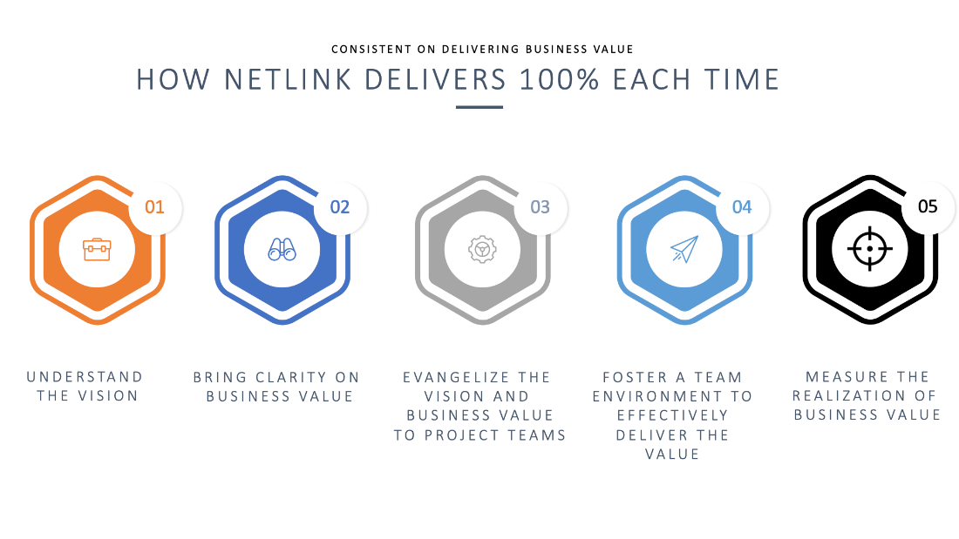

1. Project scope

Associated Alcohol & Breweries Limited (AABL) - Automating their Invoice processing for SAP ECC 6.0

**Assumptions:**

1. Fill in the assumptions
2. Proposed Solution

Netlink proposes following options to fulfil the requirements:

**Solution and Features to be described**

**Features:**

**Save time with best-in-class cognitive capture:** Enjoy the labour-reducing benefits of improved extraction rates. Adaptive, artificial intelligence-based capabilities improve document processing speed and extraction precision.

**Streamline invoice processing with workflow automation:** Native workflows ensure proper routing of invoices, enforced approval policies and greater transparency into how processes are executed.

**Automate invoice processing with broad ERP integration:** AP Essentials configures to accommodate unique vendor requirements. The suite integrates with ERP and pay-to-procure market leaders like Microsoft D365 Business Central, Microsoft D365 Finance and Operations, Oracle Financial Cloud, Oracle NetSuite and Coupa Spend Management.

**Experience low TCO and fast ROI**: Leverage existing systems and reduce overhead on hardware that depreciates over time. Achieve ROI quickly and painlessly with simple implementation, comprehensive 24/7 cloud-based support and constant performance monitoring.

**Increased data accuracy:** Invoice and purchase order data is extracted using market-leading cognitive capture technology, resulting in more accurate financial data and reduced risk of errors.

**Robust analytics:** Pre-built dashboards provide insight into invoice status and exceptions, and “zero-touch” processing and supply continuous feedback to further optimize the invoice process.

**Improved supplier relationships:** Faster, rules-driven invoice processing reduces late-payment penalties while securing early payment discounts and improving supplier relationships.

**Reduced IT requirements:** Set-up requires no hardware or software investment or time-consuming maintenance, upgrades, or updates.

**Intelligent Line-Item Extraction:** Machine learning optimizes line-item extraction that improves with each invoice processed. The result is highly efficient 2-way (invoice to purchase order) and 3-way (invoice to purchase order and goods delivered) line-item matching.

**Approval Workflows and GL Coding**: Configurable rules-driven approval and exception workflows make for quicker processes. User-assisted GL coding and image storage provides additional capabilities for end-to-end invoice automation.

**KPI/SLA Management**: Track and manage key performance indicators and SLAs associated with your invoicing process to gain insight into how work is getting done, where money is being spent and why.

**ERP Integration**: Leverage out-of-the-box integration to route validated data into your existing ERP systems and positively impact ROI without having to embark upon expensive custom integration projects.

**On-the-fly customizations**: Create your own custom cloud manufacturing ERP software. Map your most important data by adding custom fields in your forms. Customize form behavior by auto-fetching values, hide fields based on user roles, and create custom print formats — all without a single line of code.

Execution Approach

Project Methodology

Planning

The planning phase is the initial stage where you define the project goals and objectives, develop a project plan, and gather information about the organization's requirements. This phase includes the following steps:

* Identifying stakeholders and forming a project team
* Defining the scope and objectives of the project
* Conducting a feasibility study to determine the system's suitability for the organization.
* Developing a project plan with timelines, budgets, and resources
* Defining the roles and responsibilities of team members
* Identifying risks and potential roadblocks

Analyze

The analysis phase involves analyzing the current business processes and identifying areas that require improvement. This phase includes the following steps:

* Gathering requirements from stakeholders
* Documenting the existing business processes
* Analyzing the existing processes to identify gaps and inefficiencies.
* Developing a requirements document that outlines the new system's functionality.

Design

The design phase involves designing the new system based on the requirements document developed in the analysis phase. This phase includes the following steps:

* Developing a system architecture that meets the organization's requirements
* Designing the database schema
* Developing the user interface
* Developing the software modules

Development

The development phase involves implementing the design and building the system. This phase includes the following steps:

* Developing the software modules
* Configuring the database
* Integrating the software modules
* Testing the system

Deployment

The deployment phase involves deploying the system into the production environment. This phase includes the following steps:

* Preparing the production environment
* Installing the software modules
* Configuring the system
* Migrating data from the old system to the new system
* Testing the system in the production environment

Post Deployment

The post-deployment phase involves maintaining the system after it has been deployed. This phase includes the following steps:

* Providing user training and support.
* Continuously improving the system based on user feedback.

Timeline

Team Structure

The following team structure would be used in the project for either of the options.

* Project Manager
* Developers

1. Financials

Netlink will implement the project with onsite presence of consultants at Bhopal and costings for the project are described as following:

|  |  |
| --- | --- |
| Description of Services | Amount |
|  |  |
| Annual Support (Optional) |  |

**Taxes**

* Taxes, duties etc. will be applicable extra based on billing region.

**Payment Terms**

* Invoicing & Payment Terms: Fee will be invoiced upon completion of each milestone described in the table below, payable within thirty (30) days of invoice date.

|  |  |
| --- | --- |
| **Milestone** | **Payment Schedule** |
| Contract Sign / Work Order | 20% |
| Team Mobilization | 20% |
| Development Completion | 20% |
| Validate (UAT) | 20% |
| Go-Live | 20% |